Caitlyn Jones
Prof. Yangyang Wang
MATH 40A: Intro to Applied Math
6 November 2024
Lab 4
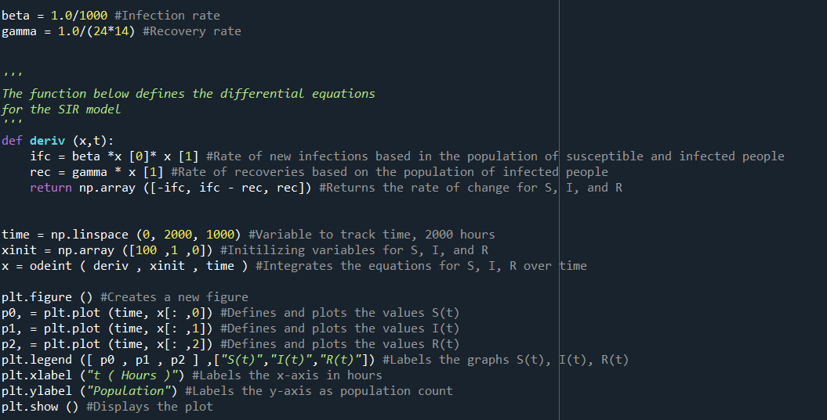
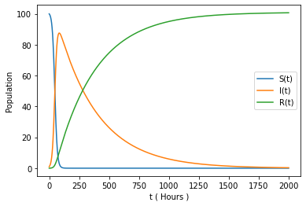
- S(0) for this model is 100, as you can see from the graph and by looking at the first value in x[:, 0]. S(0) of the model from class was 999. We can round this number up to 1000, which will allow us to assume that the model from class is directly proportional to the model from this homework.
- To modify the function so that time is measured in weeks instead of hours, I first changed the rate of infection and rate of recovery from per hour to per week.
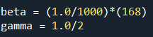

Then, I updated the value of time, so that the function is graphed over a period of weeks not hours.

Here are the results. The graph looks the same as before due to the scaling of the numbers. Because we are changing both rates and the period of time, we will receive the same progression on both graphs.
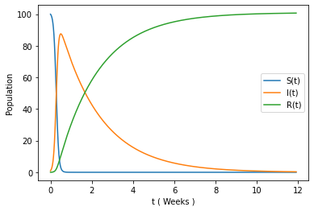

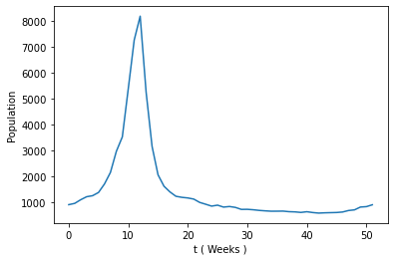
- Below is the plot of the first year of data.

When trying to fit the data, I had a little trouble with the changing the parameters. The closest I got was when I changed the parameters for time, initial values, and gamma.
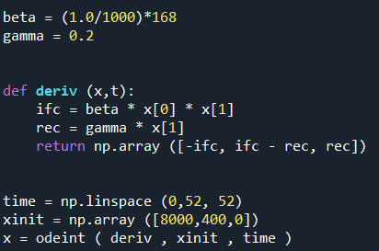

Below are the results.
